ASSIGNMENT 1

Steps to Perform the Experiment:
Step 1: Open Power BI Desktop and import the Financial Sample.xlsx file using Get Data.
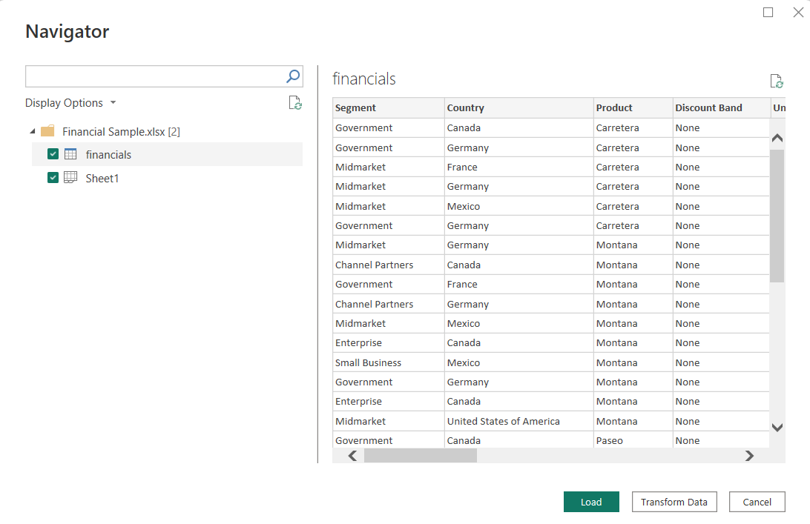
Step 2: Select the financials , sheet 1 worksheets and click Transform.
Step 3: Analyze the Orders table and identify measurable values and descriptive attributes for the model.
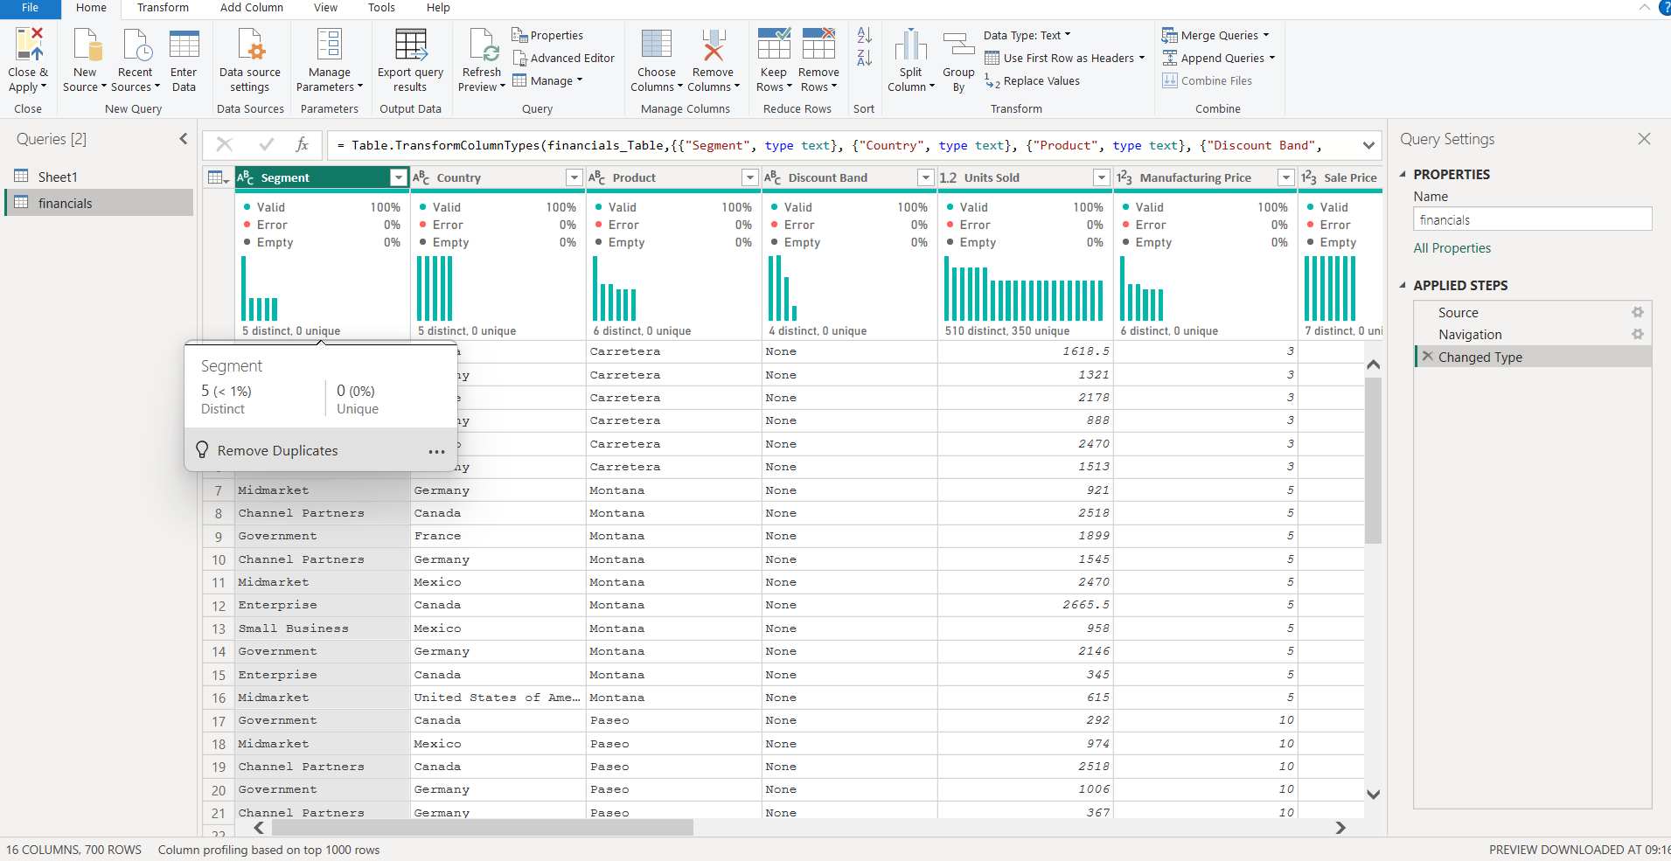

Step 4: Remove duplicate records from the tables and remove blank rows and apply.

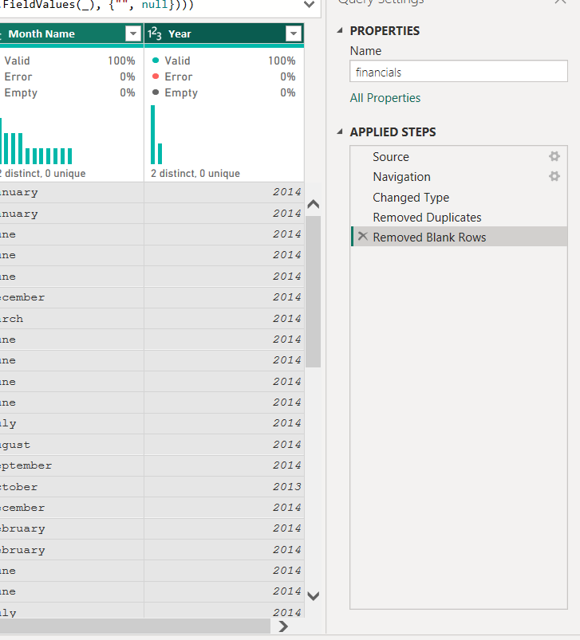

Step 5: Open Model View and create Many-to-One relationships.
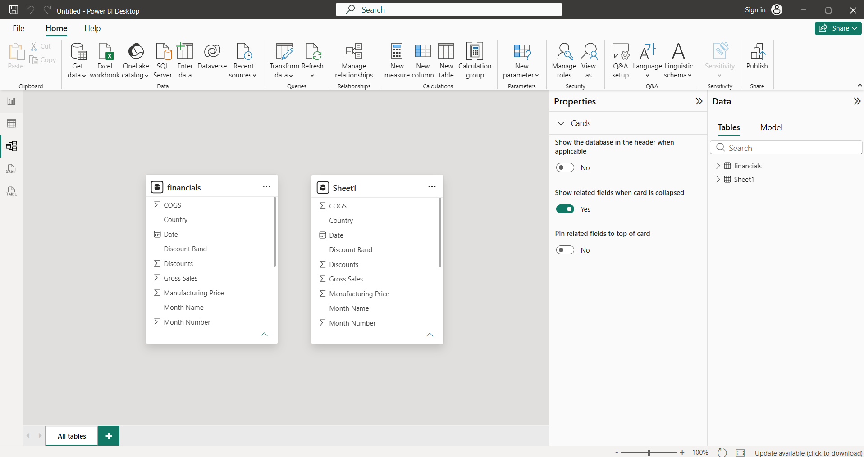

Step 6: Create Sales, Profit, and Sales Trend visualizations along with DAX measures such as Total Sales and Total Profit.
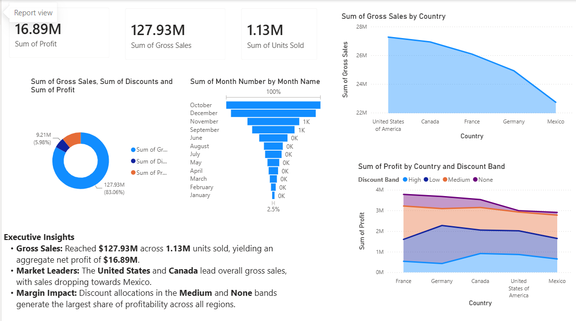

Learning Outcomes
- Understand the concepts of dimensional modeling and Star Schema architecture.
- Differentiate between Fact Tables and Dimension Tables.
- Design a dimensional model using a real-world business dataset.
- Create and validate relationships between Fact and Dimension tables in Power BI.
- Develop DAX measures for analytical reporting.

